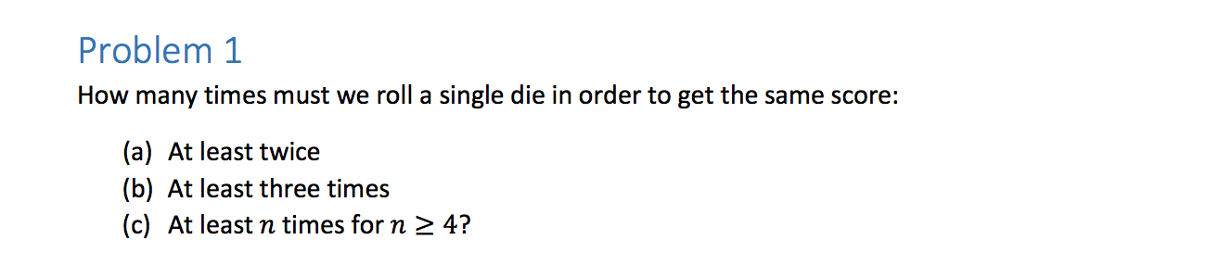

1. At least twice.

I can get any number for my first number, so the probability is 1.

Then since, P (F = getting the same number) = 1, and P(total) = 6, by the pidgeonhole principle, with six numbers, I must roll the dice **seven** times to get the same score. The first time being picking any number I want, the other six adding up to a probability of 1.

1. At least three times.

First, I have a 6/6 chance of getting any arbitrary dice value, with a probability of 1. That’s 1 roll. Then, I must roll six more times, since P(F = getting one value) = 1 / P(S) = 1/6, and by the pidgeonhole principle, if I have six possible numbers, I must roll 7 rolls. Finally, I must roll the dice another six times to ensure that I get the same number three times, since P(E) / P(S) = 1/6, where E = rolling the dice a third time. So that’s **13** rolls.

1. At least n times for n >= 4

The function then becomes **6n + 1 = number of rolls** to get the same score. The 1 represents the first roll, and the six represents every roll afterwards. Since the pidgeonhole principle states that I must choose one more than the amount of numbers that exist, to ensure that at least n are present.

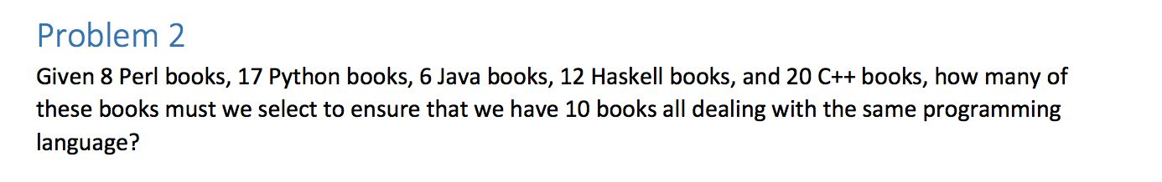

There are a total of 63 books.

Let’s analyze the worst case scenario.

First, you get all the java books. That’s six, not ten, so you grab more.

Then, you get all the Perl books, which is eight.

Then, you have 12 Haskell books and 20 C++ left.

By the pidgeonhole principle, there is no possible way there couldn’t be ten programming books if you grab at least 19 more, since there are 18 books. Nine each. So grab one more, and it equals 10. Once you get 9 of each of the remaining books, that total comes to 18. If you grab one more, by definition you must have 10 programming books.

So that’s a total of **33** books.

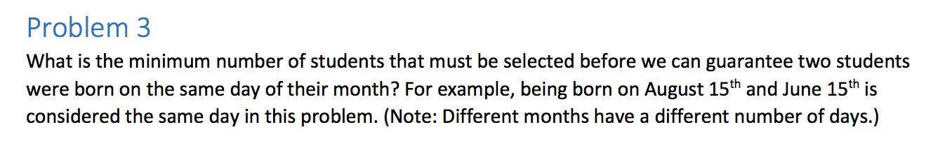

There are a maximum of 31 days in each month and a minimum of 29. You could pick 31 students, and all of them could be born on a different day. However, since there are only 31 days, by the pidgeonhole principle, if you picked 32 students there is no possible way that two of them would not have the same day of birth. Therefore, you must pick at least **32.**

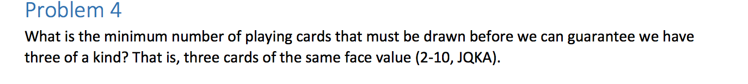

We have 52 cards, 13 of each face value. Thus, based on the pidgeonhole principle, I will define several statements.

F: Pick the first card.

G: The second card is equal to the same face value of the first card.

H: The third card is equal to the same face value.

So the P(F) = 1, because you can pick any card to start.

So you pick one card, then to make sure you have the same face value the second time, you must pick 26 cards. The worst case scenario in this case is that you get doubles of every single card. Then, if that’s the case, based on the pidgeonhole principle, you must choose a total of **27 cards.**

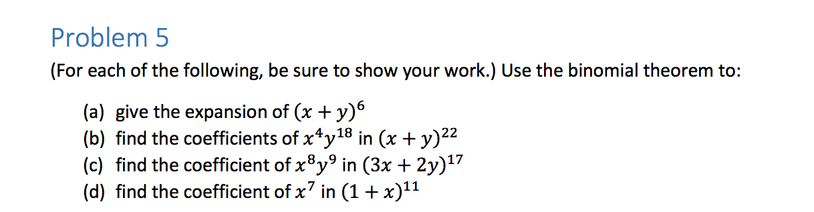

1. (x+y)6 = nk=0Σ (nk) xkyn-k

That equals: (60)x0y6 + (61)x1y5 + (62)x2y4 + (63)x3y3 + (64)x4y2 + (65)x5y1 + (66)x6y0

(60) = (66) = 1

(61) = (65) = 6! / 1! 5! = 6

(62) = (64) = 6! / 4!2! = 30 / 2 = 15

(63) = 6! / 3!3! = 30*4 / 6 = 20

y6+ 6xy5 + 15x2y4 + 20x3y3 + 15x4y2 + 6x5y + x6

1. If the coefficient attached to y is 18, and the coefficient attached to x is 4, that means that k = 4 and n – k = 18. Since k = 4, n must be 22.

Since n = 22, we know the coefficient is (224)

Thus, the answer is 22! / 4! 18! = 22*21*20*19 / 24 = **7,315**

1. (3x + 2y)17 Find the coefficient of x8y9.

Let A = 3x, and B = 2y

(A + B)17

The binomial theorem states that (A + B)n = nk=0Σ(nk)xkyn-k

So to get the coefficient, we know that k = 8 and n-k = 9, therefore n = 17.

At n = 17, we get (178)A8B9. (178) equals 17! / 8! 9! = 17*16*15*14*13*12*11*10 / 8*7*6*5*4*3*2 = 24, 310. Now we just need to plug A and B back in.

So the term becomes 24, 310 (3x)9(2y)8 = 24, 310 (19, 683)(256)x8y9 =

**122494394880**

1. (1 + x)11 Find the coefficient of x7.

The binomial theorem states that nk = 0Σ(nk) xkyn-k.

Let y = 1. Then, the problem becomes (x + y)11.

In order to get a coefficient of x7, k must be 7 and n-k = 11, so n = 18.

At n = 18, the term becomes (187)x7y11.

(187) = 18! / 7! 11! = 18*17*16*15*14*13*12 / 7*6*5*4*3*2 = 31,824. Since y = 1 and 111 = 1, our answer is just

**31, 824.**

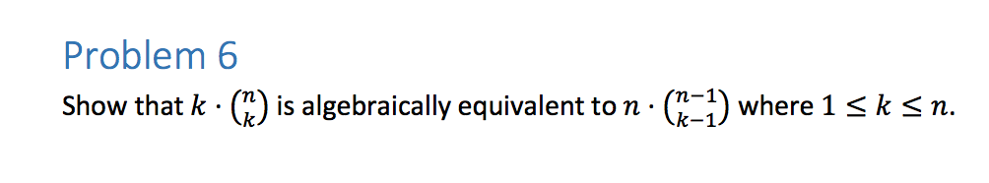

Equation 1: Algebraically, k (nk) = k * n! / (n-k)! * k!.

n! by definition means multiply by 1 less than n until you reach 1.

Thus n!=n (n-1)!. Same for (n-k)!

(n-k)! = (n-k)(n-k-1)(n-k-2).

Thus, our equation becomes k(n)(n-1)! / (n-k)! (k)(k-1)!.

The k’s cancel out leaving:

(n)(n-1)! / (n-k)! (k-1)!

Equation 2: Also, n * (n-1k-1) = n * (n-1)! / (n-1 – (k – 1))! * (k-1)!

This becomes n(n-1)! / (n – k -1 + 1)! (k-1)!

Which equals n(n-1)! / (n-k)! (k-1)!

Thus, the equations must be equal. ☺